Online Course Preparation and Facilitation

Preparation

Two Weeks Prior to First Class

Syllabus Section (main menu):
- Add contact information to the syllabus document.
- Add/modify any instructor-specific course policy information (late assignments, due dates, etc.).
- Make any additional changes to the syllabus document and ensure that the updated copy is uploaded in the Syllabus section.
- Set up due dates for assignments – this can be done via the assignment list in the Syllabus section, in the Assignments section (hidden from student view), or in individual assignments via the modules.

Profile/Bio:
- Review your Profile to ensure it is up to date.

Modules:
- Check the Instructor Resources section (hidden from students) to see if there are any pertinent documents or instructions for the class.
- Consider modifying the names of the weeks to reflect the start dates (e.g. Week 1: October 12; Week 2: October 19, etc.).
- Set up release dates for weeks to be published (if desired). All content is automatically set to open to students.

Discussion Board:
- From the main Discussion Board section, set discussions to be either unavailable (to open manually later) or set release dates based on the upcoming block/semester. Generally, you will leave the Ask the Class, Expectations, Intros, and Week 1 available and hide the remaining discussions until you are ready to publish them. Note: setting due dates and availability (see the Syllabus section above) will accomplish the same goal.

Grade Book:
- Ensure that the total points listed in the grade book match total points on the syllabus.
- Ensure that if the course uses weighted grades that the weights are correct in the Syllabus section and align with the syllabus.

Announcement:

- Send an initial announcement that lets students know:
  - That the syllabus is available
  - When the class will start
  - When content will be available
  - Reminder to purchase the textbook (if applicable)

Facilitation

Start of Class

Welcome Announcement:
- Send a couple of days before or the first day of class depending on when you want to give students access to the course content.
- Provide a brief introduction to the course and detail any preliminary activities that need to be completed in the Start Here module.
- Consider using Kaltura to do a brief overview of the syllabus and course structure (location of resources, assignments, discussions, etc.).

Make Module Items Available:
- The Start Here, Syllabus, Discussion Board, and Weekly modules should be available. Release the weeks one or two at a time or all at once, depending on how you would like to pace the class. You can set this up to automatically happen based on date preferences.
- Go to Student View to ensure that students can see the menu items. You can do this from the Home page menu on the right side of the page.

Week 1 of Class:
- Respond to student introductions and welcome them to the class.
- Monitor access to the course via the People tab - reach out to students who have not accessed the course by midweek. To view analytics per student, navigate to People, then click on the kabob (three vertical dots) menu. Select Analytics.
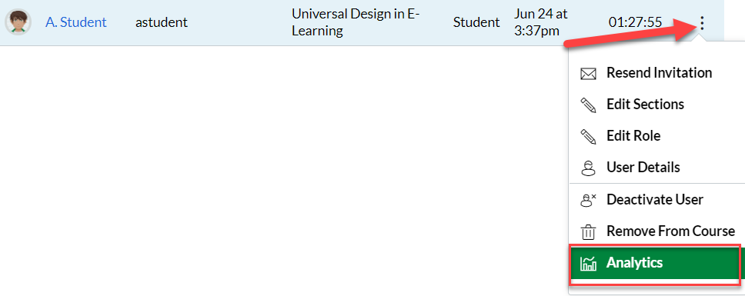

Communication

Announcements (Weeks 1 - 7):
- Post an introduction for each week (Monday morning posts help to establish the week).
- Post a midweek announcement. These posts work well for summarizing grades for the previous week and sharing other pertinent information (you may not have grades available during Week 1, but a brief check-in helps to establish presence).
- Post an end-of-the-week announcement to remind students what is due and when.
- Post additional announcements as needed (reminders for upcoming projects, etc.), but keep them succinct.
- Consider video/screencast posts using Kaltura where applicable.

Grading/Feedback

Grading:
- Consult rubrics for grading criteria.
- Ensure that points align with the university’s 100-point grading system (e.g. if an assignment is 5 points, giving a 4 will result in a C+, while giving a 4.5 will result in a B+).

Feedback
- Feedback should be substantive and personalized for each student.
- Address students by name when giving feedback.

Timing of Feedback:
- Having the previous week’s feedback available by midweek (Wed/Thurs) aligns well with the weekly introduction and midweek check-in announcements (beginning Week 2). Meaning, for the introduction you can tell students when the previous week’s grades will be available.
- For the midweek announcement, you can communicate that grades and feedback are available and provide any summary statements about the assignments/discussions that were graded.

Student Support:
- Periodically check the People area to see if any students have not logged in for an extended period. You can also deduce activity from looking at missing grades/zeroes in the grade book.
- Utilize Early Alerts in myWilmU within the first two weeks of the course.

Concluding the Class

Week 7:
- Communicate any important information about final projects/assignments.
- Remind students when the course will end (the weekly intro or midweek check-in announcement is an effective time to do this).
- For the final announcement, let student know when they can expect a final grade.

After Week 7:
- If possible, provide feedback on final assignments on the same schedule as previous weeks.
- Transfer (manually) final grades into myWilmU. Because you will see both percentages and letter grades in the grade center, you can round letter grades as needed when entering them into myWilmU. For example, a 94.5% is an A-; rounded up a half-point it becomes an A.
- Post an announcement to students to let them know that final grades are available in Canvas and in myWilmU.

